Exploring research methods from an international perspective: KomSI hosted Dr Nicole Brown (Institute of Education, University College London) for a workshop about creative approaches to data collection and analysis
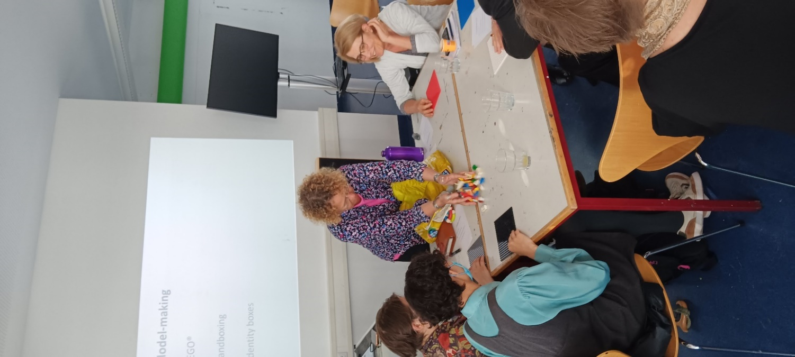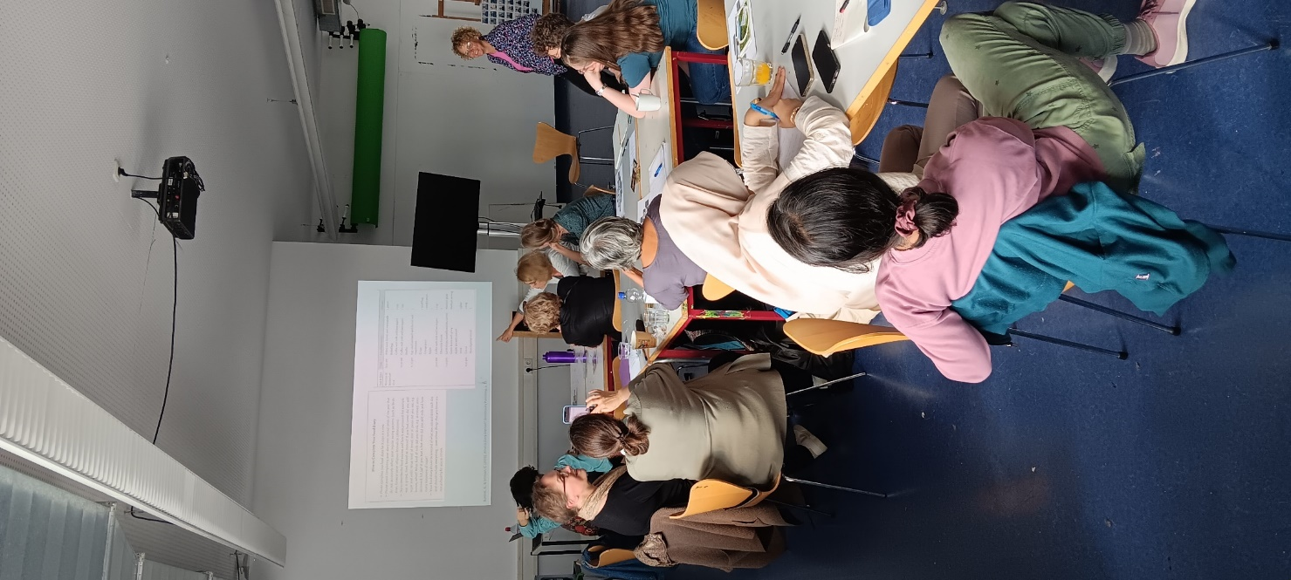
The Competence Centre for Social Intervention Research (KomSI) hosted a workshop by Dr. Nicole Brown during Frankfurt University of Applied Sciences‘ International Week in Social Work and Health. Brown, associate professor and Head of Research Ethics and Integrity at the renowned Institute of Education (University College London) travelled to Frankfurt with a suitcase full of artistic materials to allow a hands-on experimentation with the methods she uses in her own research and teaching. As an example, on Thursday the participants used LEGO® to sculpture their own researcher journeys and then reflect on practical and ethical implications for collecting data through such novel approaches. On Friday, participants used poetry to make sense of already collected, transcribed interview data. Both days illustrated how conventions in data analysis are increasingly challenged by artists-as-researchers on an international level. Brown, whose recent book publications include Photovoice Reimagined and Making The Most of Your Research Journal (both Polity Press) referred to the current acclaim for arts-informed approaches to research as the ‚creative turn‘, a paradigm shift similar to the narrative, spatial or the more recent participatory turn in the social sciences.
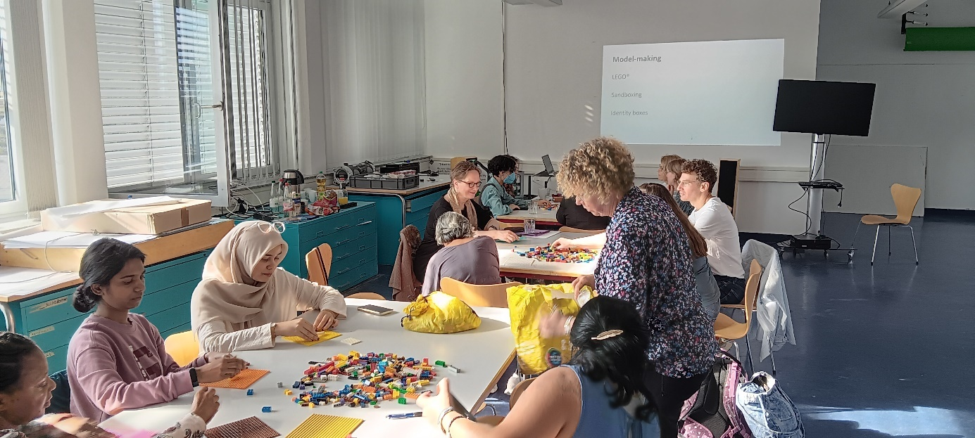The team of the KomSI research institute intended to bring to the very foreground such methodological innovations which are currently only at the fringes of qualitative research in Germany. Michaela Köttig, professor in the faculty of social work at Frankfurt University of Applied Sciences and speaker for KomSI emphasised: „We can now make use of such approaches that are much more established in other countries such as the UK thanks to Nicole’s workshop. We are dealing with vulnerable groups as research participants in our fields of research in social work and creative research methods can help us address them in multi-layered ways. Dr Brown has given us insights into many creative methods of data collection and analysis which show us new ways to do research“.
To make this other way of doing social sciences research more visible on campus, KomSI teamed up with the Brown Bag Session, a new networking format for researchers organised by Sabrina Khamo, research promoter of the faculty. A shepherd’s hut was installed on campus, in which Dr. Christian Hanser, postdoc at KomSI, shared with the guests of the faculty’s International Week how using this space for artistic expression had informed his own doctoral research. This ‚tiny house‘ encounter space is one more example how creative approaches to research interrupt fixed research protocols and invite us to engage differently with research participants (be this with LEGO®, poetry or public installations). KomSI offers regular networking events about contemporary debates in qualitative research and provides a research lab in qualitative methods open to all doctoral researchers from the four faculties within the university. For further information: christian.hanser@fb4.fra-uas.de
Further links:
https://www.frankfurt-university.de/de/hochschule/fachbereich-4-soziale-arbeit-gesundheit/forschung-am-fb-4/forschungsinstitute/kompetenzzentrum-soziale-interventionsforschung/komsi-startseite/
https://www.nicole-brown.co.uk/dr-nicole-brown/
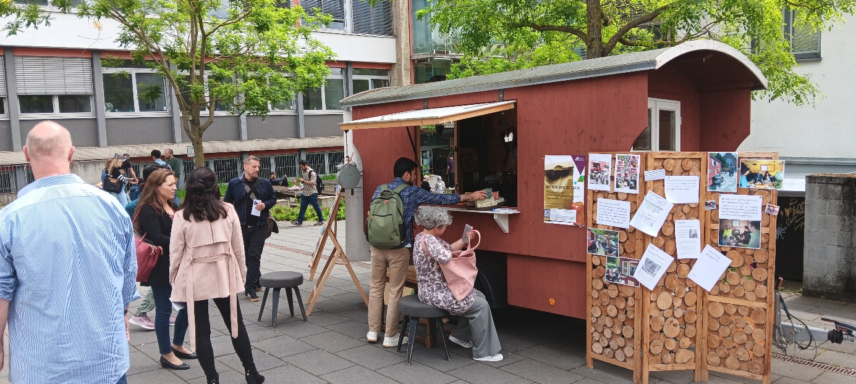
Source (all images): Christian Hanser

